A Minute a Mangrove! 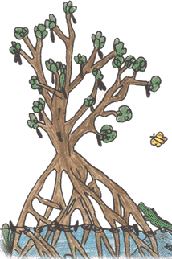 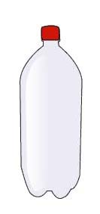
Bring in Red Mangrove propagules (seeds) and earn community service hours! For each mangrove, receive a minute of service with a 30 mangrove minimum. We will be cultivating the props for bay replenishment by Sarasota County and various estuary groups. We need over 5000 mangroves, so get out and search the bay and beaches.
CAUTION: do NOT pick sprouting mangroves from the sand because they are protected by law. Only bring in free-floating or stranded propagules! COUNT and RINSE the propagules. Place in a bag or box and label with your name and grade.
No access to propagules? No problem! Bring in RINSED 2 liter bottles, cut half-way through the label. Then peel the label off. You can receive 3 Eagle points per bottle.

A Minute a Mangrove!
Bring in Red Mangrove propagules (seeds) and earn community service hours! For each mangrove, receive a minute of service with a 30 mangrove minimum. We will be cultivating the props for bay replenishment by Sarasota County and various estuary groups. We need over 5000 mangroves, so get out and search the bay and beaches.
CAUTION: do NOT pick sprouting mangroves from the sand because they are protected by law. Only bring in free-floating or stranded propagules! COUNT and RINSE the propagules. Place in a bag or box and label with your name and grade.
No access to propagules? No problem! Bring in RINSED 2 liter bottles, cut half-way through the label. Then peel the label off. You can receive 3 Eagle points per bottle.

