Microgreens
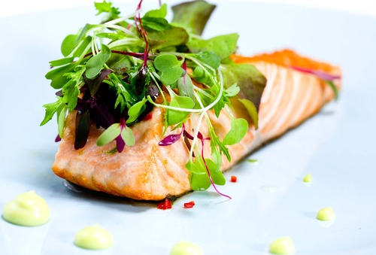
CHECK the menu of a fine restaurant or the produce section of a specialty grocery store, and you're likely to spy microgreens: tiny, delicate greens that add color, texture and flavor to a variety of foods as a garnish or ingredient.

Big on nutrition and flavor, microgreens can be expensive to purchase. But they can also be grown cost-effectively at home, in a tiny space and with simple supplies. If you have a sunny windowsill, a shallow container, some potting mix and suitable seeds, you've got all the essentials for growing your own microgreens. This is a great crop for urban gardeners who are limited to a windowsill, balcony or fire escape.

What are microgreens?
Also known as "vegetable confetti," microgreens are sometimes confused with sprouts — germinated seeds that are eaten root, seed and shoot. Microgreens are the shoots of salad vegetables picked just after the first leaves have developed. Microgreens pack nutritional punch. Researchers evaluated levels of four groups of vital nutrients, including vitamin K, vitamin C, vitamin E and beta-carotene in 25 different commercially grown microgreens.

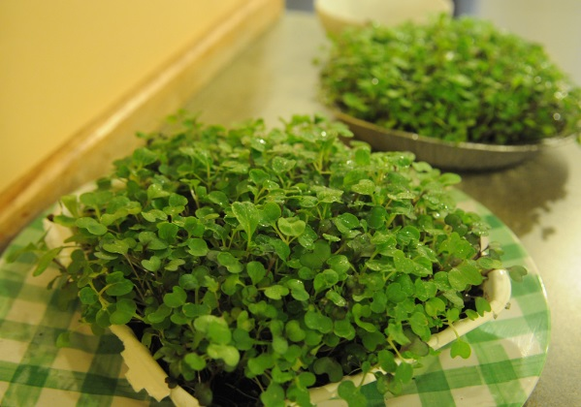

Which seeds work best?
The list of possible plants is almost endless: cabbage, beets, kale, kohlrabi, basil, cilantro, mizuna, mustard, radishes and swiss chard can be grown as microgreens. Beginners often start by growing one type of fast-germinating seeds such as radishes.
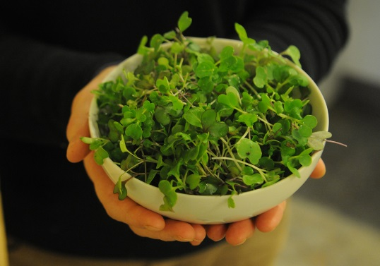
You can also find seeds for salad mixes and specially selected microgreen mixes that combine greens with similar growth rates, compatible flavors and beautiful coloring including reds, purples and greens. Since they were created with grower success in mind, they're also a good choice for beginners.

Where do I begin?
Start with a warm, sunny windowsill (direct sunlight from a south-facing window is ideal) and a small, clean container. Plastic take-out dishes and disposable pie plates work well, as do clear 2 liter bottles and salad boxes.
- Cover the bottom of the container with an inch or two of moistened soil. Flatten and level it with your hand, taking care not to over-compress it.
- Scatter seeds evenly on top and cover with a thin layer of soil.
- Dampen the surface with a mister.
- Place the container in the dark and keep and keep moist.
- Once seeds have sprouted and are about one inch tall, place in sunlight and continue to mist once or twice a day. If they become “leggy” (too long a stem-falling over), then increase the amount of light.
- Harvest when sprouts have developed their first set of leaves by cutting them near the surface of the soil.
- To serve, wash the microgreens with water and dry with paper towels or a salad spinner. Add to soups, salads, sandwiches or main dishes. Store remaining cut microgreens in a plastic bag in your refrigerator.
NOTE: you can use coco coir instead of soil, but you will need to use nutrient solution, not water.

